First Fit Algorithm and Memory Allocation

David Graves
Colorado State University Global
CSC507
Dr. Joseph Issa
August 3, 2025

Memory Allocation
Most modern computers require memory in some form or fashion to boot up and run processes. There are different types of memory including RAM and ROM with the primary function of the former (RAM) to provide a platform for the CPU to store and access instructions to perform tasks. Furthermore, ‘memory management’, which includes controlling and coordinating the memory available through block assignment aligned to running tasks is considered, “the most important function of an operating system”. (Brooks, 2024) There are different types of algorithms, or ways, that can be used to help manage memory efficiently including best-fit, first-fit, and next-fit. These refer to the way processes are designed to occupy open memory to execute. I’ll use the remainder of this paper to explore what a first-fit algorithm looks like and how it works by testing it against varying memory block and process sizes. I’ll also share how that differs from a best-fit algorithm and provide some meaningful examples where best-fit might be preferrable to use.
First Fit Algorithm
As mentioned above, the first-fit algorithm is one of a handful of ways that programmers can help manage contiguous memory allocation within modern operating systems. The first-fit algorithm performs as one might expect where, “the operating system starts searching from the beginning of the memory and allocates the first free partition that is large enough to fit the process”. (Khanzada, 2023) I’ve created a Python program shown in Image 1 below and ran a test to simulate the first-fit algorithm for memory allocation with the initial results from the Terminal displayed in Image 2.

Image 1 (Python First Fit Algorithm)
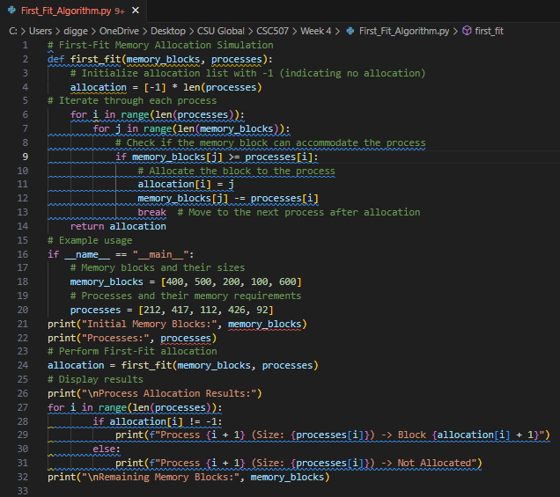
Image 2 (Python Terminal output)
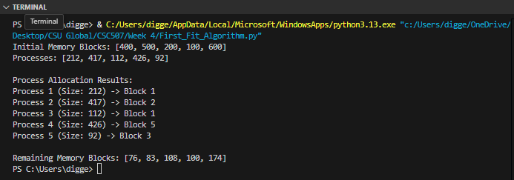
This initial run of the algorithm shows how it performed with initial memory blocks of [400, 500, 200, 100, 600] and processes sized [212, 417, 112, 426, 92]. It appears that the algorithm operated well as the processes slotted against memory in a first-fit fashion aligning to the first memory block available that could accommodate the process size. The algorithm does this by allowing the user to input memory block and process size to be used in the simulation. The logic of the algorithm then checks each memory block assigned to see if the next in line process can fit, and if so, it is sent there reducing the memory block size and then moving to the next process until completion. Finally, the algorithm displays the output of memory and process size input, the process allocation results, and the remaining memory blocks. As another test example, I’ve run the algorithm again with initial memory blocks of [100, 300, 250, 500, 400] and processes sized [110, 250, 480, 75, 300], with the following output shown in Image 3.
Image 3 (Python Terminal output)
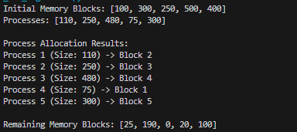
As seen above the program successfully aligned according to first-fit principals with this second attempt where the first process had to move past the first memory block to align with Block 2 and subsequent processes moved past unavailable slots until they landed in memory blocks that could accommodate their size. The first-fit algorithm above performs well in many cases, but there may be certain circumstances where one might want to use a different algorithmic type, like best-fit.
Best Fit Algorithm
The best-fit algorithm is a programming technique where its aim differs from first-fit in that it looks to minimize wasted space without consideration for efficiency. Instead of just working down a list and picking the first available memory slot, it searches for the smallest available memory block that can accommodate the process then assigns it there. Although first-fit is a simpler algorithm and should run faster than best-fit, one of the benefits of the latter is that with its added complexity it minimizes the number of unusable memory fragments leading to a more efficient use of memory. In turn this reduces memory fragmentation and enhances overall reliability. One good example where best-fit makes more sense than first-fit is in flight control systems where developers rely on these, “…techniques to manage fragmentation, ensuring reliable system operation”. (Harvie, 2023) Best-fit algorithms are also used in advanced driver assistance systems (ADAS) to help minimize fragmentation and provide more reliable real-time performance. Overall, the best-fit approach is best used when fragmentation should be avoided and where efficiency is an acceptable trade-off for more reliable performance.
Reflection
This was an interesting exercise in spinning up a first-fit algorithm in Python to test the concepts recently explored in the companion text and online content. I found that by inputting different memory block and process sizes into the algorithm, it brought the memory management concept to life for me. Diving deeper into the why and how by comparing first-fit against best-fit principles also helped me understand when one might prefer to use one approach over the other. I agree with Williams Stallings when he mentions, “the first-fit algorithm is not only the simplest bust usually the best and fastest as well” (Stallings, n.d.), but this exercise clearly showed there’s a case to be made for different types of memory management based on the use-case.
References
Brooks, Nathaniel (2024, August 12). Guru99.com. Memory Management in OS: Contiguous,
Swapping, Fragmentation.
Memory Management in OS: Contiguous, Swapping, Fragmentation
Harvie, Lance (2023, August 8). Medium.com. RTOS Memory Fragmentation: Analysis and
Mitigation Strategies.
https://medium.com/@lanceharvieruntime/rtos-memory-fragmentation-analysis-and-mitigation-strategies-ea3acfd4773e
Khanzada, Adeena (2023, April 30). Medium.com. Contiguous Memory Allocation: First Fit,
Best Fit, and Worst Fit.
Contiguous Memory Allocation: First Fit, Best Fit, and Worst Fit | by Adeena Khanzada | Medium
Stallings, W. (n.d.). Operating Systems: Internals and Design Principles, 9/e.
Retrieved from https://platform.virdocs.com/read/2228445/82/#/4/2[P7001013869000000000000000002BDA]/10[P7001013869000000000000000002C41]/16[P7001013869000000000000000002C4F]/10[P7001013869000000000000000002C54]

